CS440 MP1 Report

Andong Jing ajing2 - 3 credit In charge of DFS and multiple dots search

Siping Meng smeng10 - 3 credit In charge of BFS and Sokoban

Siyu Tao siyutao2 - 3 credit In charge of A* & Greedy and 1.2 extra

# Basic pathfinding

## BFS

The algorithm expands shallowest unexpanded node. We implemented the algorithm with a queue data structure which stores a tuple containing player’s coordinates and used a numpy array to store the nodes visited.

### Medium maze

Solution cost (# of steps): **104** # of expanded nodes: **634**

### Big maze

Solution cost (# of steps): **156** # of expanded nodes: **1261**

### Open maze

Solution cost (# of steps): **53** # of expanded nodes: **573**

## DFS

For DFS, we just basically use a queue to store all the nodes accessible and go through one specific path until it reaches the dead end, and then switch to another path, until we find the path that can reach the goal. During the process, we have a ‘visited’ matrix to store the visited node and to avoid going back to visited node.

### Medium maze

Solution cost (# of steps): 466 # of expanded nodes: 124

### Big maze

Solution cost (# of steps): 899 # of expanded nodes: 524

### Open maze

Solution cost (# of steps): 628 # of expanded nodes: 181

## Greedy

The greedy algorithm is guided by the heuristic of Manhattan distance between the current point and the goal. The point with the least Manhattan distance to the goal in the frontier will be selected to expand. The process is repeated until a path to the goal is found. The “parent” dictionary will keep track of the parent of any reached points and help print a complete path.

### Medium maze

Solution cost (# of steps): 116 # of expanded nodes: 143

### Big maze

Solution cost (# of steps): 234 # of expanded nodes: 293

### Open maze

Solution cost (# of steps): 53 # of expanded nodes: 198

## A*

The A* algorithm is guided by the heuristic of the Manhattan distance between the current point and the goal plus the cost to reach the current point. The point with the least heuristic to the goal in the frontier will be selected to expand. The process is repeated until a path to the goal is found. The “parent” dictionary will keep track of the parent of any reached points and help print a complete path.

### Medium maze

Solution cost (# of steps): 104 # of expanded nodes: 513

### Big maze

Solution cost (# of steps): 178 # of expanded nodes: 1116

### Open maze

Solution cost (# of steps): 53 # of expanded nodes: 474

# 1.2 Search with multiple dots

We used a combination of BFS and A* algorithm to guide the search.

For this condition, it is obvious that the shortest distance between each pair of points will never change, and our goal is always to find a sequence of path starting from the starting point and iterate through all the other points.

At first, we wanted to list all combination of the nodes and find the shortest one. However, it will take O(n*n!) memory and will use O(n!) time. Even the tiny search will use up my 16 GB memory. Then we notice that we can break it through by using A* search, since we know the shortest distance between each pair of nodes and we just want a shortest path to iterate through all the dots. In our A* search, the g (cost) is just the total distance traveled, and the h(heuristic) is the total distance of the minimum spanning tree of all the remaining dots which is admissible since the minimum spanning tree is the minimum way of connecting all the remaining dots, but the actual cost is the shortest path to iterate the remaining dots, which is also one of the spanning trees. So, the heuristic is guaranteed to be less than or equal to the actual cost.

## Tiny search

Solution cost (# of steps): 35 # of expanded nodes: 1129

## Small search

Solution cost (# of steps): 124 # of expanded nodes: 16576

## Medium search

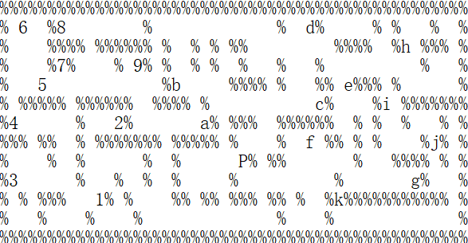Solution cost (# of steps): 198 # of expanded nodes: 828

# 1.2 Extra Credit

We used a combination of greedy algorithm and A* algorithm to guide our search. The algorithm will first find the nearest dot and mark it the current goal. Then, a* algorithm used in 1.1 will find the optimal route to that nearest dot. The process is repeated until no dots are left in the maze. According to our output, the solution cost is **353 steps** and **883 nodes** are expanded. While choosing the nearest dot as the goal does not guarantee optimality, we compensate the algorithm by incorporating a* search, which makes sure the optimality to each “current goal”.

# 2. Sokoban

For this part of the MP1, we only implemented BFS method to finish the Sokoban problem. While implementing this Sokoban solver, we created a class called state, which contains several different information in each state, including every boxes’ coordinates and the player’s coordinates. To test if the two states are the same, we set a save part inside the state class which is composed of player’s coordinates and boxes’ coordinates. If player has already attempted this coordinate while the boxes are not change, the program will skip this situation for time saving.

Another feature in our program is that we test the corner cases. If a box is pushed to a corner, then we just ignore all of the following states based on this corner state. This helped our program save a lot of costs.

Here is the solution cost and the number of expanded nodes and the running time (For BFS method):

Soko1: 0.23620009422302246; Expanded: 981; Solution cost: 33

Soko2: 0.35021018981933594; Expanded: 1752; Solution cost: 51

Soko3: 400.6101870536804; Expanded: 1752; Solution cost: 51

Soko4: 1990.596181869507; Expanded: 117405; Solution cost: 144